NAME : K.Yamini Joshna

REGISTER NUMBER : 192110710

COURSE CODE : CSA0520

COURSE NAME : DATABASE MANAGEMENT FOR DATA ANALYTICS

##### Program1

Write a function to build a string repeatedly until the value of the variable becomes s greater than 5. Then, we display the final string using a SELECT statement.

##### Procedure:

REPEAT loop

The syntax of the REPEAT loop statement is as follows:

REPEAT

statements; UNTIL expression

##### END REPEAT

First, MySQL executes the statements, and then it evaluates the expression. If

the expression evaluates to FALSE, MySQL executes the statements repeatedly until the expression evaluates to TRUE.

Because the REPEAT loop statement checks the expression after the execution of statements, the REPEAT loop statement is also known as the post-test loop.

The following flowchart illustrates the REPEAT loop statement:

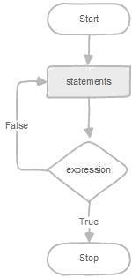

##### Program 2:

Write a function that uses REPEAT statement which would repeat the loopuntil income is greater than or equal to 4000, at which point the REPEAT loop would beterminated

